Condensate Simulation Report
HVAC Condensate Production Analysis
Psychrometric Analysis | Open-Meteo Weather Data

Project Information
Project Name | Test Tower
Project No. | MCT-2026-MEP-001
Revision | P2
Client | Test Dev
Prepared by | Hussein Ragab
Checked by | Principal MEP Review
Date | 2026-09-02

Values in this report are displayed in SI (metric) units.

1. Methodology & Standards
Reference | Application
ASHRAE Handbook — Fundamentals (2021 SI) Ch. 1 | Psychrometric equations for moist-air properties: humidity ratio Eq (8)/(20), saturation pressure Eq (5)/(6), moist-air density Eq (11) via the specific volume Eq (24)-(26), enthalpy Eq (30), thermodynamic wet-bulb Eq (33)/(35).
ANSI/ASHRAE Standard 84-1991 | Method of Testing Air-to-Air Heat Exchangers — defines sensible and latent wheel effectiveness (# 6.3.1, Eq 7) used in the heat-recovery calculations.
psychrolib (SI) / ASHRAE RP-1485 | Python implementation of the ASHRAE psychrometric equations (RP-1485: Thermodynamic Properties of Real Moist Air). Unit system: SI.
Weather Data | Hourly weather data (T, RH, surface pressure) via the Open-Meteo Archive API for 2025-01-01 to 2025-12-31. Data source: Open-Meteo archive — live fetch, site timezone Asia/Dubai, data written 2026-09-02 10:25.
Condensate Formula | Q_cond [L/h] = ṁ_dry [kg/s] × 3600 [s/h] × Δω [kg/kg dry air], where ṁ_dry = ρ·V̇/(1 + ω) is the dry-air mass flow taken at the state where V̇ is measured, and ρ is the MOIST-air density at that SAME state (Fundamentals Eq (11)). That state is the OUTDOOR wheel-inlet condition on the heat-recovery paths, the on-coil condition with no recovery (the two coincide at 100 % outdoor air), and the room condition when recirculating: dry-air mass is conserved across a wheel while V̇ is not, so the inlet is the correct basis. Δω = max(0, ω_on-coil − ω_off-coil) and 1 kg of condensate is taken as 1 L. Same identity as the # 4 step trace.
Heat-Recovery Effectiveness | Wheel effectiveness per ASHRAE 84-1991 (# 6.3.1, Eq 7): ε = Q_actual / Q_max, applied on DRY-AIR-MASS flows (ratio ṁ_min/ṁ_supply, ṁ = ρV̇/(1+ω)). Enthalpy wheels have separate sensible and latent effectiveness.

2. Design Inputs
Parameter | Value
Location | Dubai, United Arab Emirates
Simulation Period | 2025-01-01 to 2025-12-31
FAHU System Type | FAHU with enthalpy wheel only
Fresh Air Flow Rate | 12,000 L/s
Off-Coil Dry Bulb Temp | 13.0 °C
Off-Coil Condition Type | Relative Humidity
Off-Coil Condition Value | 90 % RH
Extract Air Flow Rate | 11,000 L/s
Room Dry Bulb Temperature | 24.0 °C
Room Wet Bulb Temperature | 17.0 °C
Enthalpy Wheel Sensible ε | 0.70
Enthalpy Wheel Latent ε | 0.65
Operating Schedule | Residential 24/7 (100 % 06:00-22:00, 70 % 22:00-06:00) - Mon-Fri 24 h | Sat 24 h | Sun 24 h

3. Design Assumptions
- Mid-hour averaging applied to weather data: T and RH averaged between consecutive hours to represent each hour's mean condition.
- Off-coil conditions are constant design values (cooling coil setpoints are held regardless of load variations).
- Air density is evaluated at on-coil (inlet) conditions for each hour.
- Condensate production is zero when the post-wheel supply humidity ratio is at or below the off-coil humidity ratio (Δω ≤ 0).
- Enthalpy wheel pre-conditions outdoor air before the cooling coil.
- Wheel effectiveness applied using extract air as the sink stream.
- Latent effectiveness reduces outdoor humidity ratio before the coil.
- Wheel effectiveness: the ε values in # 2 are this run's inputs. The library pre-fills behind them are MID-RANGE picks from the printed ASHRAE SE 2020 Ch.26 catalogue bands (enthalpy wheel ε_s 0.65-0.80, ε_l 0.60-0.75) - an engineering default, NOT a printed cell - use the AHRI-1060 tested values for the selected unit instead. Saved library overrides are active, so the pre-filled values are the engineer's own, not the bundled defaults.
- ASHRAE 84-1991 # 6.3.2 defines effectiveness on the enthalpy exchanged where condensation occurs on the exchanger; this tool applies the rated sensible and latent effectiveness in every hour, including condensing hours - verify against the manufacturer's condensing-condition data where the wet-coil result is design-critical.
- Room / return design conditions: the DB and WB in # 2 are this run's inputs. The library pre-fills behind them are TYPICAL cooling-season design values (ASHRAE Standard 55-2010 summer comfort zone; ASHRAE Handbook - HVAC Applications (2019) Ch. 1 / 2 / 9 / 20; ASHRAE TC 9.9 (2011) Class A1) - an engineering default, NOT a printed cell for this specific space - confirm the setpoint against the project specification. ASHRAE 55-2010 and TC 9.9 are held with the tool; the HVAC Applications handbook is cited as a design reference and is NOT bundled, so these pairs are engineering estimates, not transcribed handbook cells. Saved library overrides are active, so the pre-filled values are the engineer's own, not the bundled defaults.
- Operating schedule applied: Residential 24/7 (100 % 06:00-22:00, 70 % 22:00-06:00). Hourly capacity is the percent of design airflow; off hours draw no air (0 %). Each day of the week (Mon-Sun) follows its own 24-hour profile; the weekend is Saturday and Sunday. Pattern: Mon-Fri 24 h | Sat 24 h | Sun 24 h. Profiles were manually edited.

4. Step-by-Step Calculation
Step 1: Design-point outdoor air (peak hour)
Formula: T_o, RH_o, P from the hourly weather series (source: see # 1 Data source)
Substitution: Peak hour: 2025-09-01 21:00:00
Result: —

Step 2: Outdoor humidity ratio
Formula: ω_o = GetHumRatioFromRelHum(T_o, RH_o/100, P)
Substitution: T_o=31.90 °C, RH_o=86.0 %
Result: 0.02652 kg/kg

Step 3: Room extract humidity ratio
Formula: ω_r = GetHumRatioFromTWetBulb(T_room_DB, T_room_WB, P)
Substitution: T_DB=24.0 °C, T_WB=17.0 °C
Result: 0.00944 kg/kg

Step 4: Air-mass-flow ratio (ASHRAE 84-1991 Eq 7)
Formula: ṁ = ρ · V̇ / (1+ω); ratio = ṁ_min / ṁ_supply
Substitution: ṁ_s=13.0784, ṁ_e=12.6401 kg/s → ratio=0.9665
Result: 0.96649

Step 5: Enthalpy-wheel sensible pre-cool
Formula: T_on = T_o − ε_s · ratio · (T_o − T_room)
Substitution: ε_s=0.7, ratio=0.9665, T_o=31.90, T_room=24.0
Result: 26.6 °C

Step 6: Enthalpy-wheel latent pre-dehumidify
Formula: ω_on = ω_o − ε_l · ratio · (ω_o − ω_r)
Substitution: ε_l=0.65, ratio=0.9665, ω_o=0.02652, ω_r=0.00944
Result: 0.01579 kg/kg

Step 7: Off-coil humidity ratio
Formula: ω_out = GetHumRatioFromRelHum(T_off, RH/100, P)
Substitution: T_off=13.0 °C, RH=90.0 %, P=99,500 Pa
Result: 0.00854 kg/kg

Step 8: Moisture removed per hour
Formula: Δω = max(0, ω_on − ω_out)
Substitution: ω_on=0.01579, ω_out=0.00854
Result: 0.00725 kg/kg

Step 9: Hourly condensate
Formula: Q = ρ(T_o,ω_o) · V̇_f / (1+ω_o) · 3600 · Δω
Substitution: ρ=1.119 kg/m³, V̇_f=12.000 m³/s, Δω=0.00725
Result: 341.36 L/h

5. Results
Parameter | Value
Simulation Period | 2025-01-01 to 2025-12-31
TOTAL CONDENSATE | 850,041 L
Peak Daily Condensate | 6,280 L/day
Date of Peak | 24 Jul 2025
Average Daily Condensate | 2,329 L/day
Summer Average Daily | 3,731 L/day
Winter Average Daily | 901 L/day
Spring Average Daily | 1,603 L/day
Fall Average Daily | 3,058 L/day

Monthly Breakdown
Month | Total (L) | Avg Daily (L/day) | Peak Daily (L/day)
January 2025 | 15,451 | 498 | 1,712
February 2025 | 29,301 | 1,046 | 2,562
March 2025 | 30,248 | 976 | 2,215
April 2025 | 38,613 | 1,287 | 2,856
May 2025 | 78,598 | 2,535 | 4,295
June 2025 | 113,205 | 3,774 | 5,174
July 2025 | 120,003 | 3,871 | 6,280
August 2025 | 110,012 | 3,549 | 4,992
September 2025 | 130,757 | 4,359 | 6,187
October 2025 | 104,777 | 3,380 | 5,838
November 2025 | 42,709 | 1,424 | 3,130
December 2025 | 36,368 | 1,173 | 2,366

6. Condensate Profile
Condensate production at four aggregations: daily totals, the full hourly series, monthly totals, and the season-to-season average daily generation. Higher values typically occur during humid summer months when the difference between outdoor and off-coil humidity ratios is greatest.

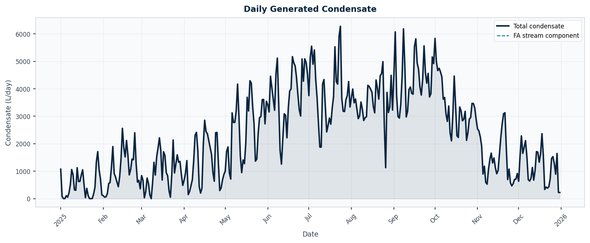

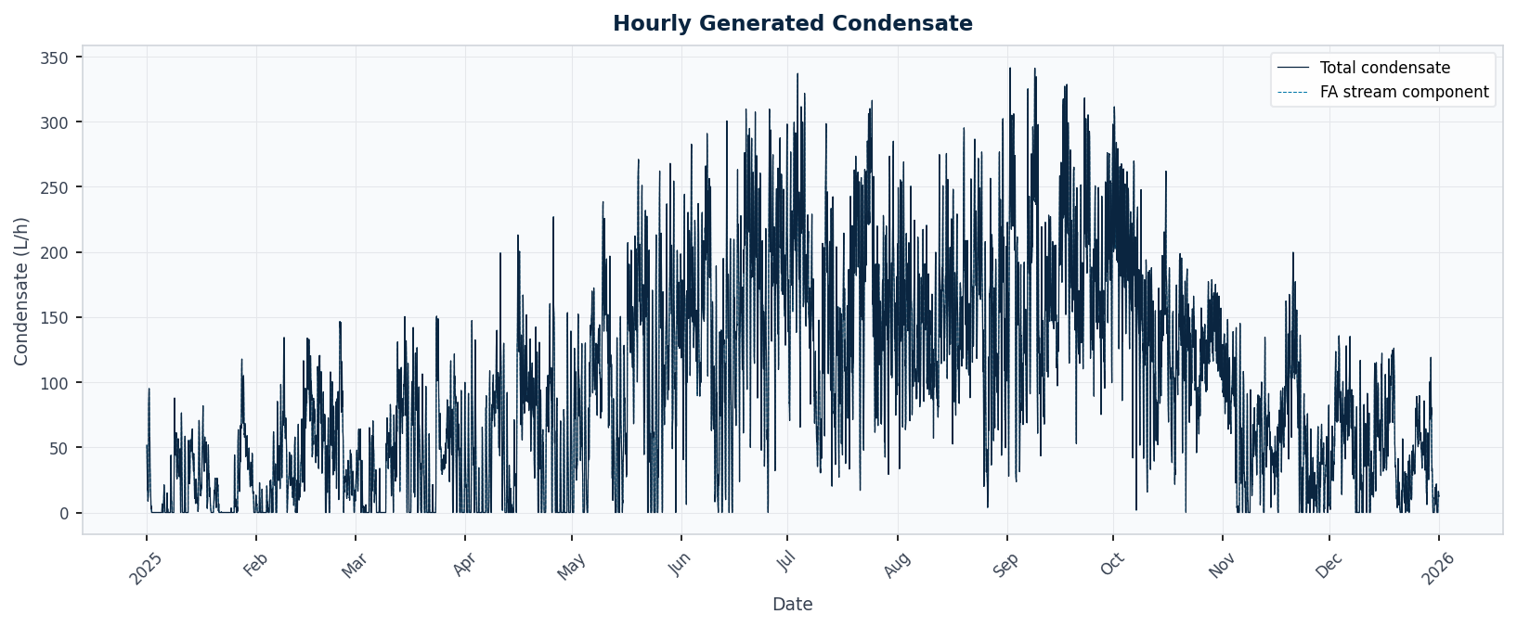

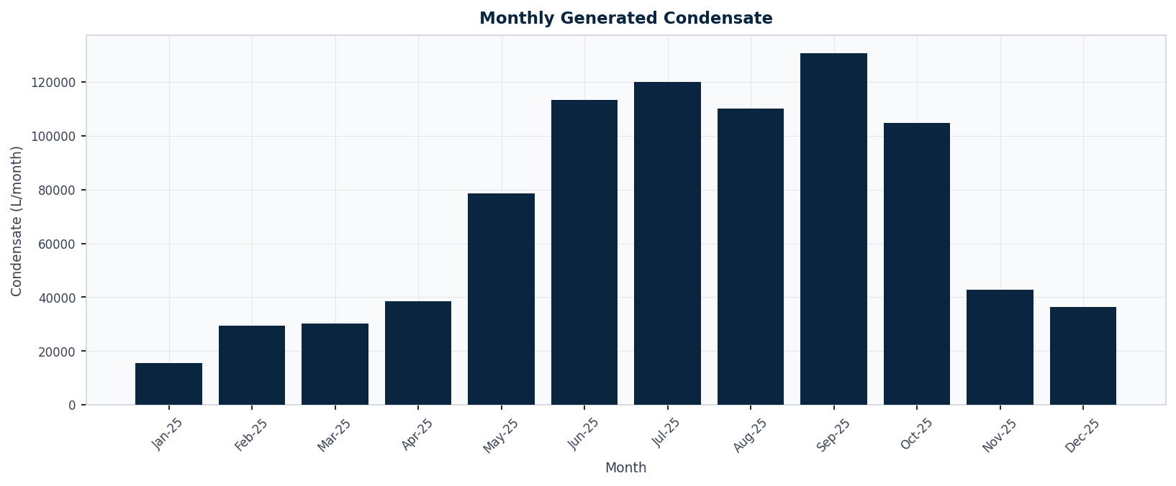

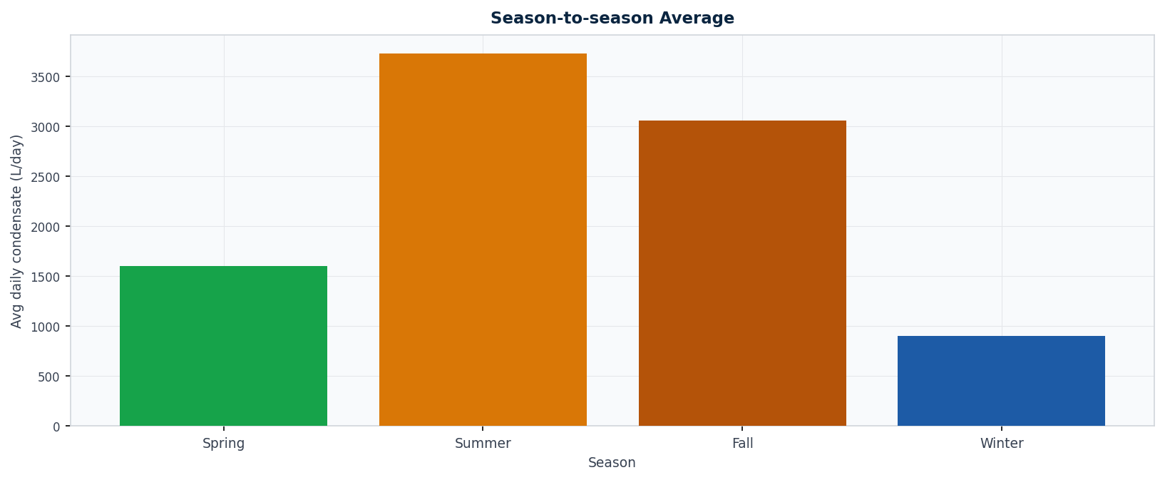

7. Condensate Recovery & Reuse
Storage and reuse assessment for the condensate computed above. The recovery tank is simulated day-by-day using the continuous daily time-series (behavioural) method of BS 8515:2009+A1:2013 # 4.1.2.4, in the context of BS EN 16941-1:2018 on-site non-potable reuse. Within each day this tool applies a yield-before-spillage convention (same-day condensate is usable the same day, reflecting continuous condensate production; neither standard prescribes the within-day draw order - EN 16941-1 Annex A illustrates a previous-day-storage variant): each day the demand is met first from stored condensate, then from potable make-up; surplus is stored up to the tank capacity and any excess overflows. The water demand is always met - the assessment quantifies how much potable make-up the condensate displaces (the saving) and how much is still purchased (the residual / diff). Collection efficiency is 100 %; the tariff is a fixed rate per cubic metre; the currency code is a label only (no FX conversion). Sources are combined by date before sizing.
Parameter | Value
Storage Tank Size | 3,520 L
Tank Sizing Basis | days-of-demand buffer (1.6 days x 2,200 L/day)
Total Condensate Collected / yr | 850,041 L
Total Water Demand / yr | 803,000 L
Condensate Used (offset) | 595,343 L
Potable Make-up (residual) | 207,657 L
Wasted Overflow | 254,698 L
Demand Met | 74 %
Water Tariff | 12 AED/m3
ANNUAL SAVING | 7,144 AED
Residual Potable Cost (the diff) | 2,492 AED

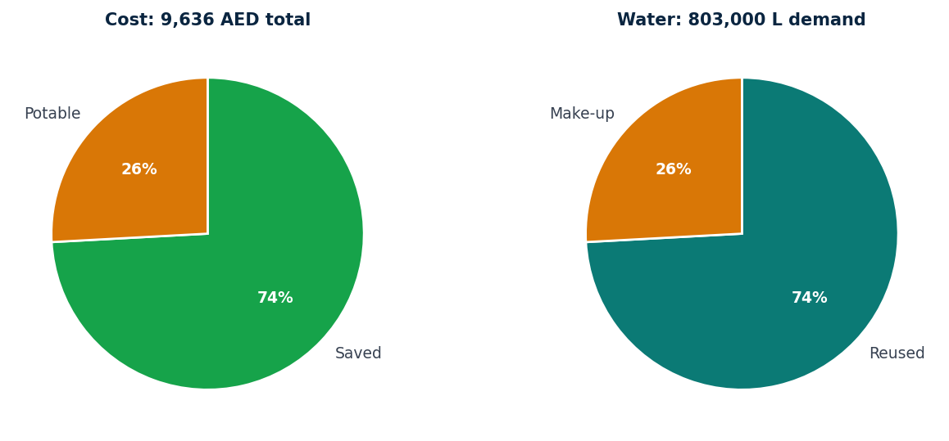
Seasonal Breakdown
Season | Condensate (L) | Demand (L) | Used (L) | Potable (L) | Wasted (L)
Mar-May | 147,459 | 202,400 | 132,057 | 70,343 | 11,881
Jun-Aug | 343,220 | 202,400 | 202,400 | 0 | 140,820
Sep-Nov | 278,242 | 200,200 | 179,765 | 20,435 | 101,997
Dec-Feb | 81,120 | 198,000 | 81,120 | 116,880 | 0

Condensate Sources
Source | Annual Volume | Marginal Saving
FAHU-01 roof enthalpy-wheel | 850,041 L | 7,144 AED

Calculation Trace
1. Sources combined by date: 1 source(s) over 365 day(s); total collected 850,041 L (850.04 m3) at 100 % collection efficiency.
2. Tank = 1.6 day(s) of demand x peak daily demand 2,200 L/day = 3,520 L (demand-anchored; condensate fills it, potable tops up the rest). The 1-day buffer is a tool advisory default - no standard attribution.
3. Daily mass-balance run with CONSTANT demand 2,200 L/day. Each day: draw condensate first, top up the rest from potable, store leftover up to the tank capacity.
- Mar-May: condensate 147,459 L, demand 202,400 L -> used 132,057 L, potable 70,343 L, wasted 11,881 L (over 92 day(s)).
- Jun-Aug: condensate 343,220 L, demand 202,400 L -> used 202,400 L, potable 0 L, wasted 140,820 L (over 92 day(s)).
- Sep-Nov: condensate 278,242 L, demand 200,200 L -> used 179,765 L, potable 20,435 L, wasted 101,997 L (over 91 day(s)).
- Dec-Feb: condensate 81,120 L, demand 198,000 L -> used 81,120 L, potable 116,880 L, wasted 0 L (over 90 day(s)).
4. Year: condensate used 595,343 L, potable make-up 207,657 L, wasted overflow 254,698 L; demand met 74 %.
5. Annual saving = used 595,343 L / 1000 x 12 AED/m3 = 7,144 AED.
6. Residual potable cost (the diff) = make-up 207,657 L / 1000 x 12 AED/m3 = 2,492 AED (potable only; sewerage/discharge not credited).
7. ADVICE: Condensate cannot meet demand even with unlimited storage - short 155,125 L/yr. Collect from more sources if possible (e.g. add FCU/FAHU units to the recovery set). Fires above 5 % of demand (tool advisory default - no standard attribution).
8. ADVICE: Supply and demand are out of phase: condensate is wasted in Mar-May, Jun-Aug, Sep-Nov while potable make-up is bought in Mar-May, Sep-Nov, Dec-Feb. A day tank cannot bridge seasons.
9. ADVICE: Optional: a larger tank would capture about 52,532 L/yr more condensate before it overflows. Fires above 5 % of demand (tool advisory default - no standard attribution).
Advice
- Condensate cannot meet demand even with unlimited storage - short 155,125 L/yr. Collect from more sources if possible (e.g. add FCU/FAHU units to the recovery set). Fires above 5 % of demand (tool advisory default - no standard attribution).
- Supply and demand are out of phase: condensate is wasted in Mar-May, Jun-Aug, Sep-Nov while potable make-up is bought in Mar-May, Sep-Nov, Dec-Feb. A day tank cannot bridge seasons.
- Optional: a larger tank would capture about 52,532 L/yr more condensate before it overflows. Fires above 5 % of demand (tool advisory default - no standard attribution).

R. Reference Standards
- ASHRAE Handbook — Fundamentals (2021 SI), Ch. 1 Psychrometrics — Moist-air property equations: humidity ratio Eq (8)/(20), saturation pressure Eq (5)/(6), density Eq (11)/(26), enthalpy Eq (30), thermodynamic wet-bulb Eq (33)/(35), adiabatic mixing Eq (44).
- ANSI/ASHRAE Standard 84-1991 — Method of Testing Air-to-Air Heat Exchangers — wheel effectiveness = actual / maximum transfer (# 6.3.1, Eq 7); applied on DRY-AIR-MASS flows m = rho*V/(1+w), ratio m_min/m_supply.
- psychrolib (SI) / ASHRAE RP-1485 — Validated Python implementation of the ASHRAE psychrometric equations (RP-1485: Thermodynamic Properties of Real Moist Air).
- BS 8515:2009+A1:2013 — Rainwater harvesting systems - Code of practice: detailed daily mass-balance storage sizing (# 4.1.2.4), applied to condensate reuse.
- BS EN 16941-1:2018 — On-site non-potable water systems - Part 1 (rainwater): reuse design and demand-matching context for the condensate recovery assessment.
- Open-Meteo Archive API — Hourly historical weather data (T, RH, surface pressure).
Library: user-edited overrides are active (file: C:\Users\enghu\AppData\Roaming\MEP Suite\condensate\library.json).
Engineer of record: Hussein Ragab
Generated by Condensate Simulator — ASHRAE psychrometric condensate analysis.

