Stairwell Pressurization Design Report
Stairwell Pressurization System | NFPA 92 / IBC 909
Smoke Control | Location: Dubai, United Arab Emirates

Project Information
Project Name | Test Tower
Project No. | MCT-2026-MEP-001
Revision | P2
Client | Test Dev
Prepared by | Hussein Ragab
Checked by | Principal MEP Review
Date | 2026-09-02

Values in this report are displayed in SI (metric) units.

1. Methodology & Standards
Reference | Application
NFPA 92 (2024) — Smoke Control Systems | Table 4.4.2.1.1 minimum design ΔP: 12.5 Pa (0.05 in. w.g.) for sprinklered (AS) buildings any ceiling height; 25 Pa (0.10 in. w.g.) non-sprinklered at 2.7 m ceiling. Evaluates stack, wind and HVAC interaction.
IBC # 909.6 / # 909.20.5 — Smokeproof Enclosures | Requires rational analysis by a licensed professional. # 909.20.5 stairway pressurization alternative: shaft held at 25–87 Pa (0.10–0.35 in. w.g.) with all doors closed.
NFPA 101 # 7.2.1.4.5 — Door Operating Force | Maximum force to set a door in motion: 133 N (30 lbf). Typical closer bias: 67 N.
EN 12101-13:2022 — Pressure Differential Systems (design) | Current European design standard (EN 12101-6 was reissued in 2022 as a kits/product specification). Table 1: door force ≤ 100 N; ΔP ≥ 30 Pa; air velocity ≥ 1 m/s (Class 1) or ≥ 2 m/s (Class 2).
BS EN 12101-6:2005 # 4.2 — Pressure-Differential Systems (superseded) | Legacy Class A basis (means of escape, all doors closed): ΔP ≥ 50 Pa; door force ≤ 100 N (governs max ΔP); flow at open door ≥ 0.75 m/s. Retained for projects designed to the 2005 edition.
ASHRAE Handbook — Fundamentals (Ch. 14 & 16) | ASHRAE 1%/99% percentile methodology for design outdoor temperatures; stack-effect theory.
Klote & Milke — Principles of Smoke Management (SFPE) | K_s = 3460 Pa·K (SI form of 7.64 in.wg·°R/ft), C_d = 0.839 SI leakage discharge coefficient, 1.15 open-door turbulence factor, and the NFPA 92 linear pressure-profile model used throughout this report.
Manual design temperatures (user-specified) | Winter / summer design temperatures entered by the engineer (1 % / 99 % annual-percentile convention, ASHRAE Ch. 14); no weather-archive fetch was used for this calculation.
Local code adoption | Confirm the locally adopted editions and amendments of the standards above with the Authority Having Jurisdiction (AHJ).
Selected design basis for this report | NFPA 92 / IBC 909 (NFPA 92 # 4.4.2.1 + IBC # 909.20.5 + NFPA 101 # 7.2.1.4) — min ΔP = 25 Pa, max ΔP = 87 Pa, max door force = 133 N.

2. Design Inputs
Parameter | Value
Location | Dubai, United Arab Emirates
Design basis | NFPA 92 / IBC 909
Stairwell conditioning | Air Conditioned
Internal setpoint | 24.0 °C
Design temperature source | Manual design temperatures (user-specified)
Winter design temperature (1 %) | 12.0 °C
Summer design temperature (99 %) | 46.0 °C
Number of floors | 41
Stairwell length | 5.4 m
Stairwell width | 2.6 m
Total stairwell height | 129.3 m
Wall leakage tightness | Tight (ratio = 1.40e-05 m²/m²)
Floor/Ceiling leakage tightness | Average (ratio = 5.20e-05 m²/m²)
Effective minimum ΔP | 25.0 Pa
Max open-door velocity | 1.00 m/s
Door closer opening force (F_closer) | 45 N
Safety margin | 10 %
Door Type 1 | Qty 41, 0.9 m × 2.1 m, crack 2.0 mm, open in fire: 3
Door Type 2 | Qty 4, 0.9 m × 2.1 m, crack 2.0 mm, open in fire: 0

3. Design Assumptions
- Manual design temperatures (user-specified); the winter / summer values represent the 1 % / 99 % annual design conditions (ASHRAE Ch. 14 convention).
- Leakage discharge coefficient C_d = 0.839 (NFPA 92 SI form; equivalent to C_d approx. 0.65 with ρ_air = 1.2 kg/m³).
- Open-door turbulence factor = 1.15 — a conservative tool allowance on the open-door airflow term; NFPA 92 methodology does not print this factor (standards echo: BS EN 12101-6:2005 # 11.2.2.2 adds a 15 % allowance for ductwork losses).
- Door-closer opening force (F_closer) = 45 N. This is the force required at the latch edge to overcome the door closer alone (with ΔP = 0). Typical values — EN 1154 size 2 approx. 25 N, size 3 approx. 35 N, size 4 approx. 45 N. A heavy US commercial closer (NFPA 101 default) is taken as 67 N. EN 1154 requires power size ≥ 3 on fire/smoke door assemblies.
- Stack effect evaluated in both seasons; the case yielding the larger ΔP governs the design (NFPA 92 Annex).
- Wind effect is NOT modelled — the calculation adds the worst-season STACK effect only. IBC # 909.20.5 requires the pressurization band to hold under maximum anticipated conditions of stack effect AND wind effect, and NFPA 92 # 4.4.2.1.4 names wind explicitly — verify wind pressures separately for exposed stairwells (advisory note; changes no computed value).
- Linear pressure-profile model with the neutral plane assumed at mid-height of the stairwell (NFPA 92 / Klote & Milke Chapter 5).
- Horizontal leakage = floor-plan area × 2 slabs × N_floors × ratio.
- Door-crack leakage = (door perimeter × crack gap) / 2 per door (one-sided flow convention).
- Injection strategy: Multi-point injection (9 points). Building height > 30.0 m — use multiple injection points (recommended every 10–15 m). 9 points suggested for this height (129.3 m). Spacing and exact locations must be confirmed with the AHJ and shall follow the rational-analysis requirements of IBC # 909.6.

4. Step-by-Step Calculation
4.1 Design Temperatures
Step 1: Winter Design Temperature
Formula: T_winter = user-specified winter design temperature
Substitution: Manual design temperatures (user-specified)
Result: T_winter = 12.0 °C
Note: Taken as the 1 % annual cold-season percentile by convention (ASHRAE Ch. 14).

Step 2: Summer Design Temperature
Formula: T_summer = user-specified summer design temperature
Substitution: Manual design temperatures (user-specified)
Result: T_summer = 46.0 °C

4.2 Internal Stairwell Temperature
Step 3: Ti — Air-Conditioned Stairwell
Formula: Ti = user setpoint
Substitution: Ti_winter = Ti_summer = 24.0 °C
Result: Ti = 24.0 °C

4.3 Stack-Effect Pressure Difference
Step 4: ΔP_stack — Winter
Formula: ΔP_w = K_s × max(0, 1/T_out − 1/T_in) × (H/2)
Substitution: 3460 × max(0, 1/285.150 − 1/297.150) × (129.30/2)
Result: ΔP_stack_w = 31.7 Pa
Note: Winter: cold outside ⇒ positive stack drives air up.

Step 5: ΔP_stack — Summer
Formula: ΔP_s = K_s × max(0, 1/T_in − 1/T_out) × (H/2)
Substitution: 3460 × max(0, 1/297.150 − 1/319.150) × (129.30/2)
Result: ΔP_stack_s = 51.9 Pa
Note: Summer: cooler inside ⇒ reverse stack.

Step 6: Governing Stack Effect
Formula: ΔP_stack = max(ΔP_w, ΔP_s)
Substitution: max(31.7 Pa, 51.9 Pa)
Result: ΔP_stack = 51.9 Pa (Summer governing)

4.4 Design Pressure Differential
Step 7: Design ΔP
Formula: ΔP_design = ΔP_min + ΔP_stack (capped at basis maximum if applicable)
Substitution: 25.0 Pa + 51.9 Pa
Result: ΔP_design = 76.9 Pa

4.5 Leakage Areas (NFPA 92 Table A.4.4.4.3)
Step 8: Wall Leakage Area
Formula: A_wall = 2(L+W) × H_total × ratio
Substitution: 2(5.4 m+2.6 m) × 129.3 m × 1.40e-05
Result: A_leak_wall = 0.0290 m²

Step 9: Floor / Ceiling Leakage Area
Formula: A_horiz = L × W × 2 slabs × N_floors × ratio
Substitution: 5.4 m × 2.6 m × 2 × 41 × 5.20e-05
Result: A_leak_horiz = 0.0599 m²

Step 10: Door-Crack Leakage Area
Formula: A_doors = Σ [N × (2W + 2H) × crack / 2]
Substitution: Sum over all door types with qty > 0
Result: A_leak_doors = 0.2700 m²
Note: Crack divided by 2 — one-sided flow convention.

Step 11: Total Leakage Area
Formula: A_total = A_wall + A_horiz + A_doors
Substitution: 0.0290 m² + 0.0599 m² + 0.2700 m²
Result: A_leak_total = 0.3588 m²

4.6 Leakage Flow Rate
Step 12: Q_leak (NFPA 92 SI)
Formula: Q_leak = C_d × A_total × √ΔP_design
Substitution: 0.839 × 0.3588 m² × √76.89
Result: Q_leak = 2.640 m³/s = 2,640 L/s
Note: C_d = 0.839 = 0.65·√(2/1.2), the SI orifice coefficient (Klote/SFPE; NFPA 92 methodology) — the substitution is in SI (ΔP in Pa).

4.7 Open-Door Flow Rate
Step 13: Q_open — Open-Door Airflow
Formula: Q_open = 1.15 × V_max × A_door × N_open
Substitution: 1.15 × 1.00 m/s × ΣA_door × N_open (total 3 doors)
Result: Q_open = 6.520 m³/s = 6,520 L/s
Note: 1.15 is the tool's conservative open-door allowance (turbulence / vena contracta at doorways); NFPA 92 methodology does not print this factor.

4.8 Total Fan Flow with Safety Margin
Step 14: Sub-Total Flow
Formula: Q_total = Q_leak + Q_open
Substitution: 2.640 m³/s + 6.520 m³/s
Result: Q_total = 9.160 m³/s = 9,160 L/s

Step 15: Final Fan Flow
Formula: Q_final = Q_total × (1 + margin/100)
Substitution: 9.160 m³/s × (1 + 10 %/100)
Result: Q_final = 10.076 m³/s = 10,076 L/s

4.9 Door Opening Forces
Step 16: Door Type 1 Opening Force
Formula: F = F_closer + (W × A × ΔP) / (2 × (W − d)) [NFPA 92 A.4.4.2.2 / BS EN 12101-6:2005 Clause 15 + Annex A]
Substitution: F = 45 N + (0.9 m × 0.9 m × 2.1 m × 76.9 Pa) / (2 × (0.9 m − 70 mm))
Result: F_closer = 45 N + F_pressure = 79 N = F = 124 N [OK]
Note: Max allowable per NFPA 92 / IBC 909: 133 N. d = handle set-back from latch edge = 70 mm.

Step 17: Door Type 2 Opening Force
Formula: F = F_closer + (W × A × ΔP) / (2 × (W − d)) [NFPA 92 A.4.4.2.2 / BS EN 12101-6:2005 Clause 15 + Annex A]
Substitution: F = 45 N + (0.9 m × 0.9 m × 2.1 m × 76.9 Pa) / (2 × (0.9 m − 70 mm))
Result: F_closer = 45 N + F_pressure = 79 N = F = 124 N [OK]
Note: Max allowable per NFPA 92 / IBC 909: 133 N. d = handle set-back from latch edge = 70 mm.

4.10 Max Allowable ΔP & Relief Vent
Step 18: Max Allowable ΔP
Formula: ΔP_max = 2 × (W − d) × (F_max − F_closer) / (W × A)
Substitution: Solved against the governing door (lowest allowable ΔP): Door Type 1 (0.9 m × 2.1 m); F_max = 133 N, F_closer = 45 N
Result: ΔP_max = 85.9 Pa

Step 19: Relief Vent Area
Formula: A_relief = max(0, Q_total / (C_d × √ΔP_max) − A_total)
Substitution: Q_total = 9.160 m³/s, ΔP_max = 85.9 Pa
Result: A_relief = 0.8193 m²
Note: Required when fan output at ΔP_max exceeds what the leakage area alone can pass.

5. Results
Parameter | Value
Design temperature source | Manual (user-specified)
Winter design T (1%) | 12.0 °C
Summer design T (99%) | 46.0 °C
Internal T — winter | 24.0 °C
Internal T — summer | 24.0 °C
Governing season | Summer
ΔP_stack (governing) | 51.9 Pa
ΔP_design | 76.9 Pa
─── LEAKAGE ───
Wall leakage area | 0.0290 m²
Floor/ceiling leakage area | 0.0599 m²
Door-crack leakage area | 0.2700 m²
Total leakage area | 0.3588 m²
─── FLOWS ───
Leakage flow | 2,640 L/s
Open-door flow | 6,520 L/s
Sub-total flow | 9,160 L/s
Final fan flow (+10 %) | 10,076 L/s
─── DOOR FORCE / RELIEF ───
Max allowable ΔP (door force) | 85.9 Pa
Relief vent area | 0.8193 m²
Injection strategy | Multi-point injection (9 points)

Design Checks
Check | Status | Detail
Min ΔP ≥ 25 Pa (NFPA 92 / IBC 909) | PASS | Effective min ΔP = 25.0 Pa, basis minimum = 25 Pa.
Design ΔP ≤ 87 Pa cap | PASS | Raw design ΔP = 76.9 Pa ≤ 87 Pa — no relief required on pressure grounds.
Safety margin applied | PASS | 10% additional margin on Q_final.
Door Type 1 force ≤ 133 N | PASS | Total 124 N (closer 45 N + pressure 79 N) ≤ 133 N per NFPA 92 # 4.4.2.1 + IBC # 909.20.5 + NFPA 101 # 7.2.1.4.
Door Type 2 force ≤ 133 N | PASS | Total 124 N (closer 45 N + pressure 79 N) ≤ 133 N per NFPA 92 # 4.4.2.1 + IBC # 909.20.5 + NFPA 101 # 7.2.1.4.
Relief vent required | INFO | A_relief = 0.8193 m²
Injection strategy | INFO | Building height > 30.0 m — use multiple injection points (recommended every 10–15 m). 9 points suggested for this height (129.3 m). Spacing and exact locations must be confirmed with the AHJ and shall follow the rational-analysis requirements of IBC # 909.6.

6. System Schematic & Pressure Profile
The schematic below shows a single-zone stairwell section with pressurization fan(s) and (if required) relief vent. The pressure-profile chart shows ΔP across each floor door, with code-minimum and door-force-limited bounds shaded for reference.

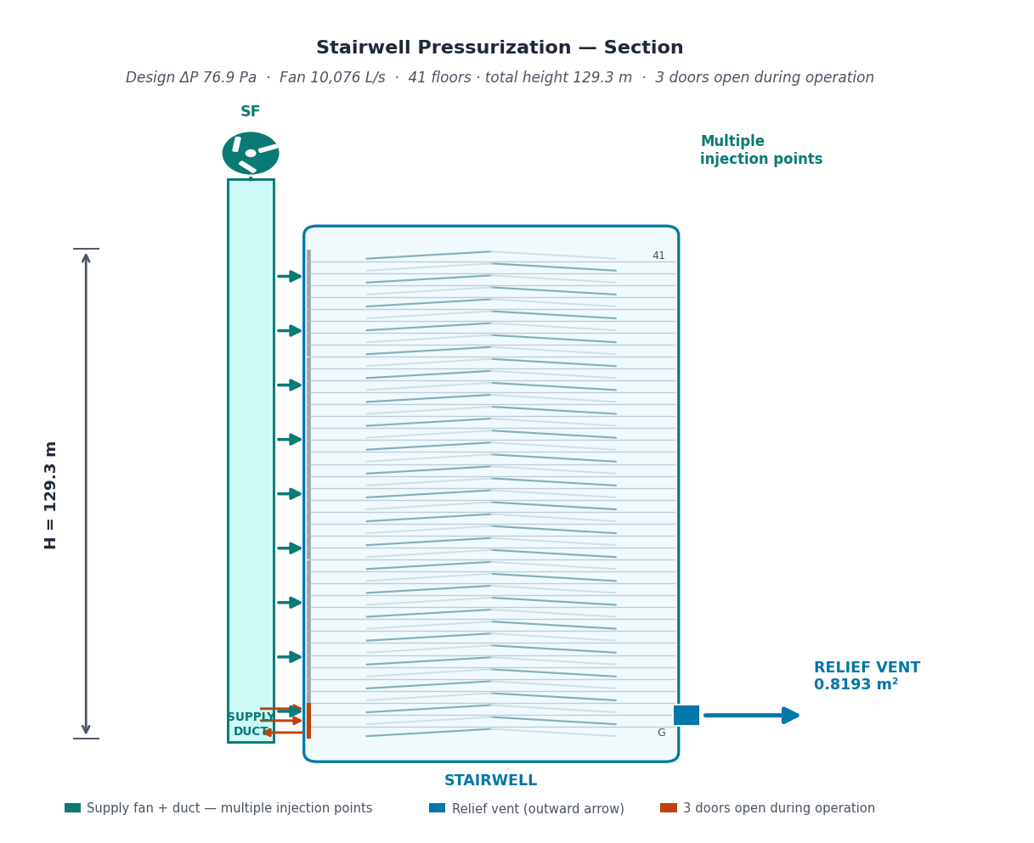
6.1 Pressure Profile (per NFPA 92 linear model)
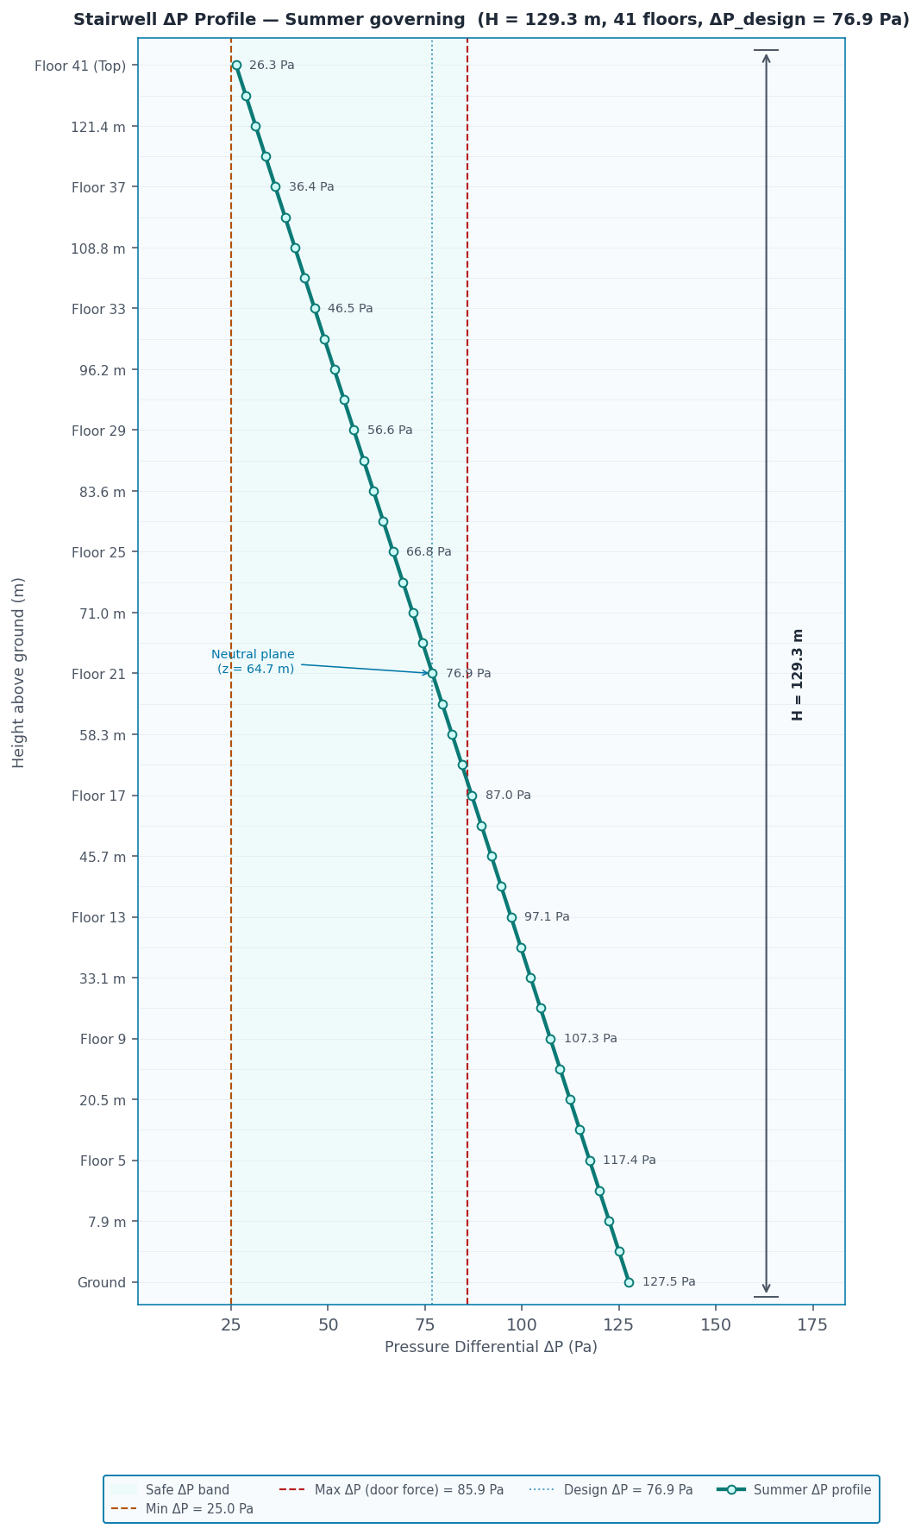

7. Pressurization Fan & Motor Schedule
Parameter | Pressurization Fan | Unit
Service | Stairwell pressurization | —
Tag | SF-1 … SF-2 | —
Quantity | 2 | nos.
Injection points | 9 (multi-point injection (9 points)) | —
Flow per fan | 5,038 | L/s
Design ΔP | 76.9 | Pa
Duct system losses | 0.0 | Pa
Total fan static | 76.9 | Pa
Fan efficiency | 65 | %
Absorbed shaft power | 0.60 | kW
Motor efficiency | 91 | %
Motor input power | 0.65 | kW
Selected motor (× 1.15 SF) | 0.75 | kW

Notes
1. Fans are constant-speed (non-VFD). Pressurization runs on receipt of fire-alarm signal; fan speed and motor selection assume steady-state operation at the design ΔP.
2. All fan motors shall be connected to the EMERGENCY power source (generator or equivalent) in accordance with NFPA 92, IBC # 909.6, and the local fire code. Normal-to-emergency transfer time shall not exceed the activation requirements of the smoke-control system.
3. Motor selection applies a safety factor of 1.15 to the absorbed shaft power; the nearest IEC preferred motor rating at or above that value is selected (0.37 – 400 kW series).
4. Air-injection arrangement — Spacing and exact locations must be confirmed with the AHJ and shall follow the rational-analysis requirements of IBC # 909.6.
5. Fan and motor efficiencies are user-specified inputs. Fan operating point (flow, static) must be confirmed against the manufacturer's published curves before procurement.

R. Reference Standards
- NFPA 92 (2024) — Smoke Control Systems — Pressurization-system methodology; minimum design ΔP and stack/wind/HVAC interaction (Chapter 4, Table 4.4.2.1.1).
- IBC # 909.6 — Smokeproof Enclosures — Pressurization method by rational analysis; demonstrated by calculation.
- NFPA 101 # 7.2.1.4.5 — Door Operating Force — Maximum force to set a door in motion.
- BS EN 12101-6:2005 # 4.2 — Pressure-Differential Systems — Class A (means of escape) criteria (ΔP, door force, open-door velocity).
- BS EN 1154 — Controlled Door Closing Devices — Closer power sizes — source of the EN closer opening-force presets (size 2 approx. 25 N, 3 approx. 35 N, 4 approx. 45 N, 5 approx. 55 N); minimum power size 3 on fire/smoke door assemblies.
- ASHRAE Handbook — Fundamentals (Ch. 14 & 16) — Design outdoor temperatures (1%/99% percentile) and stack-effect theory.
- Klote & Milke — Principles of Smoke Management (SFPE) — K_s stack constant, leakage discharge coefficient, open-door turbulence factor and the NFPA 92 linear pressure-profile model.
Engineer of record: Hussein Ragab
Generated by Stairwell Pressurization Calculator — NFPA 92 / BS EN 12101-6 stairwell smoke control.

